# 

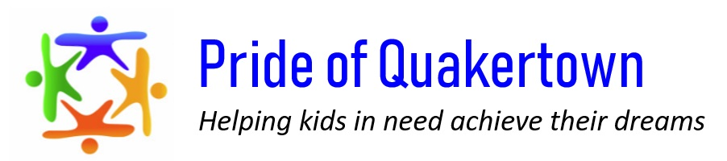

Corporate Sponsorship

Registration Form

*Platinum ($2,500)*

*Gold ($2,000)*

*Silver ($1,500*

*Bronze ($750)*

*Email sponsor logo to* [*prideofquakertown@yahoo.com*](mailto:prideofquakertown@yahoo.com)*.*

*Send check made out to Pride of Quakertown and registration form to P.O. Box 437 Quakertown, PA 18951.*

Create a Custom Sponsorship Arrangement

Don't see the package that best suits your needs? On a tight budget? These are just sample sponsorship packages that can be customized to your needs. Also if you think you may be suited better to be an event sponsor, just check off what may interest you below and someone will be in touch.

# Company Name__________________________________________

# Company Address ________________________________________

# _______________________________________________________

# Contact Name ___________________________________________

# Contact Phone Number ___________________________________

Contact Email ___________________________________________

Sponsorship Levelevel

How Important Are Extracurricular Activities?

Avoiding Risky Behavior

Extracurricular activities are a healthy and safe alternative to many of the risky behaviors that adolescents may participate in if they have free time. After-school activities or activities on weekends keep adolescents active and focused. Having these activities also makes adolescents more confident about their future and more likely to develop goals. Without extracurricular activities adolescents can turn to drugs and crime to fill their time and curb their boredom.

Preparing For College or Career

Extracurricular activities are beneficial and arguably, even crucial in preparing for college or a career. Identifying abilities early on and working to perfect the skills associated with those abilities may help lead students towards a certain career path. Furthermore, the team-building and collaboration skills gained from extracurricular activities with others become useful in both college and career environments.

Facilitation of Friendships

Extracurricular activities help to facilitate friendships. Whether the extracurricular activity is a sport, band or other hobby it is sure to include others and encourage interaction. Being around others with similar interests is a great way to facilitate long-lasting, close friendships, which are crucial for our mental health and even physical health.